**ASSIGNMENT -2**

**Connect to the Store Sales Data and do the following: -**

**− Remove all the blank rows.**

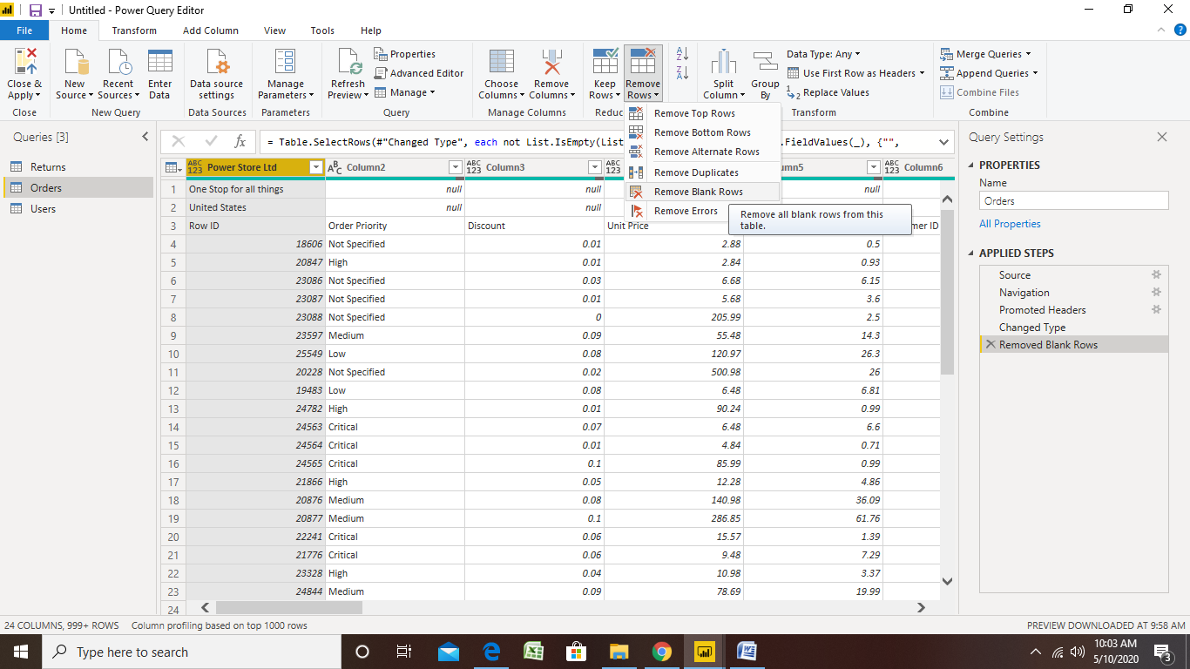

**Update the column header if they are not updated –**

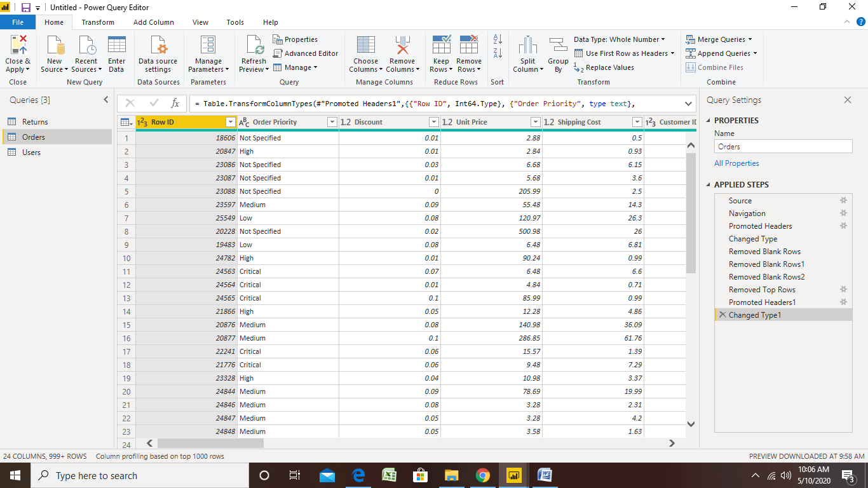

**Create a text table and show the sales in terms of o Customers**

**o Product Category**

**o Regions**

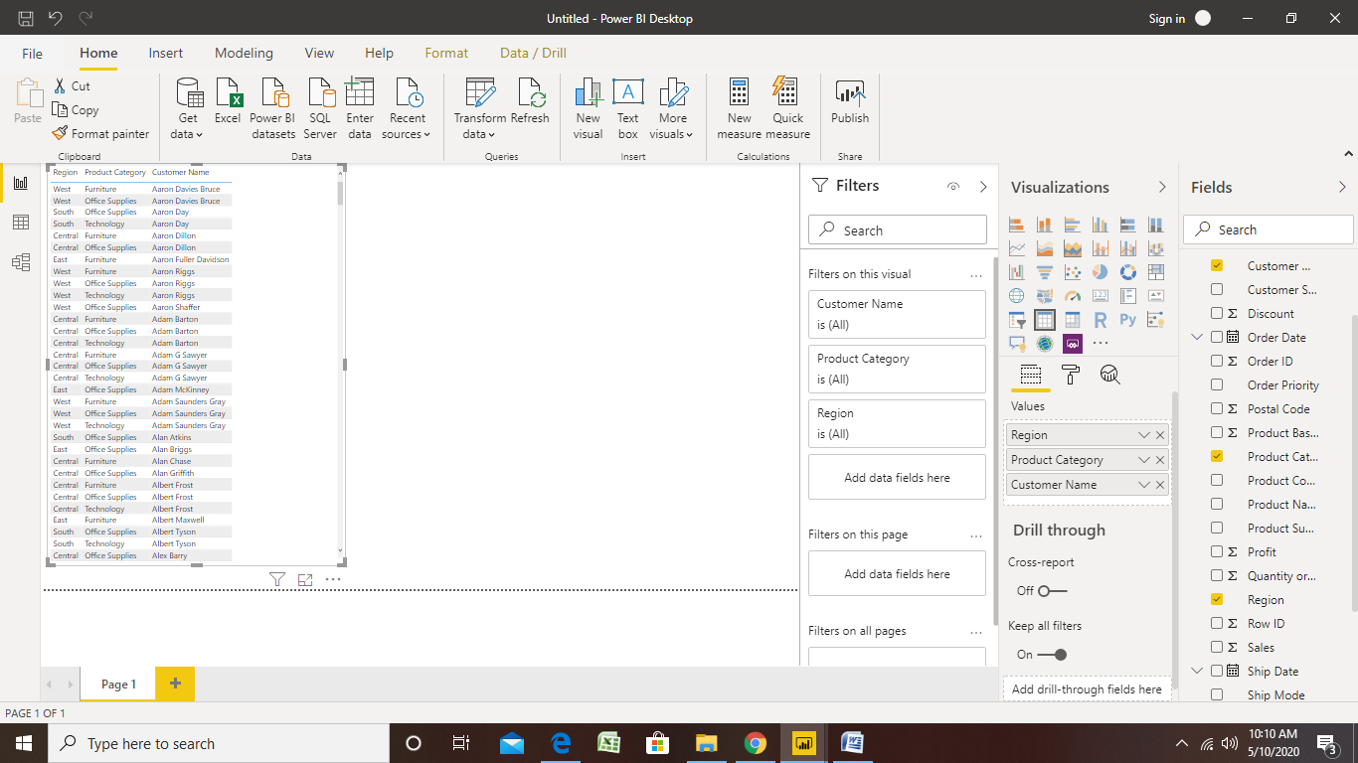

**Create a line and Clustered Column Chart showing the Sales and Discount as per the State or Province**

**Format the bars and line with different colors**

**LINE CHART:**

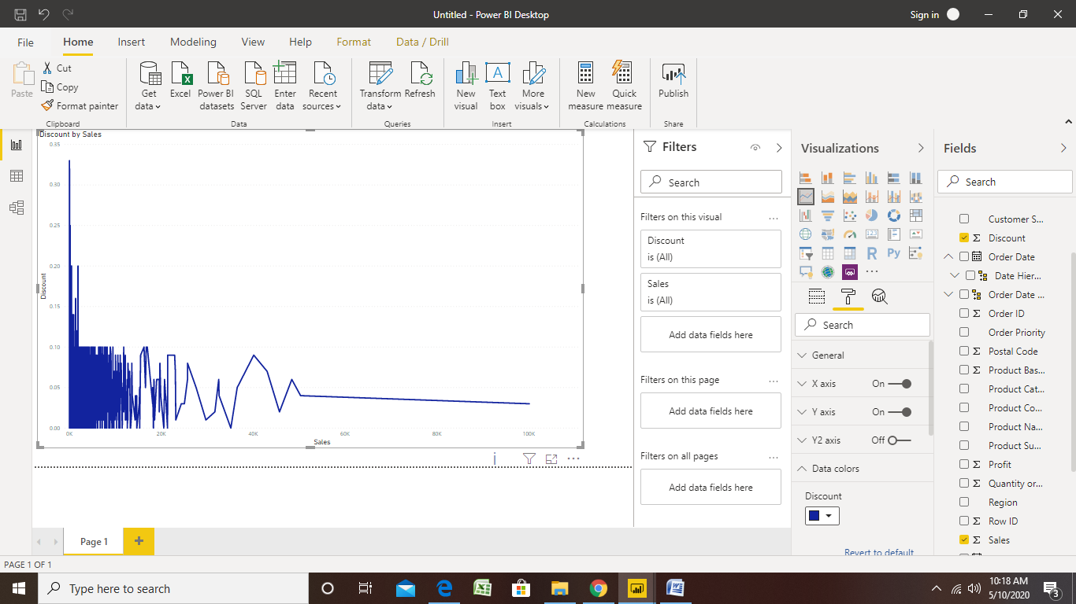

**Clustered Column Chart :**

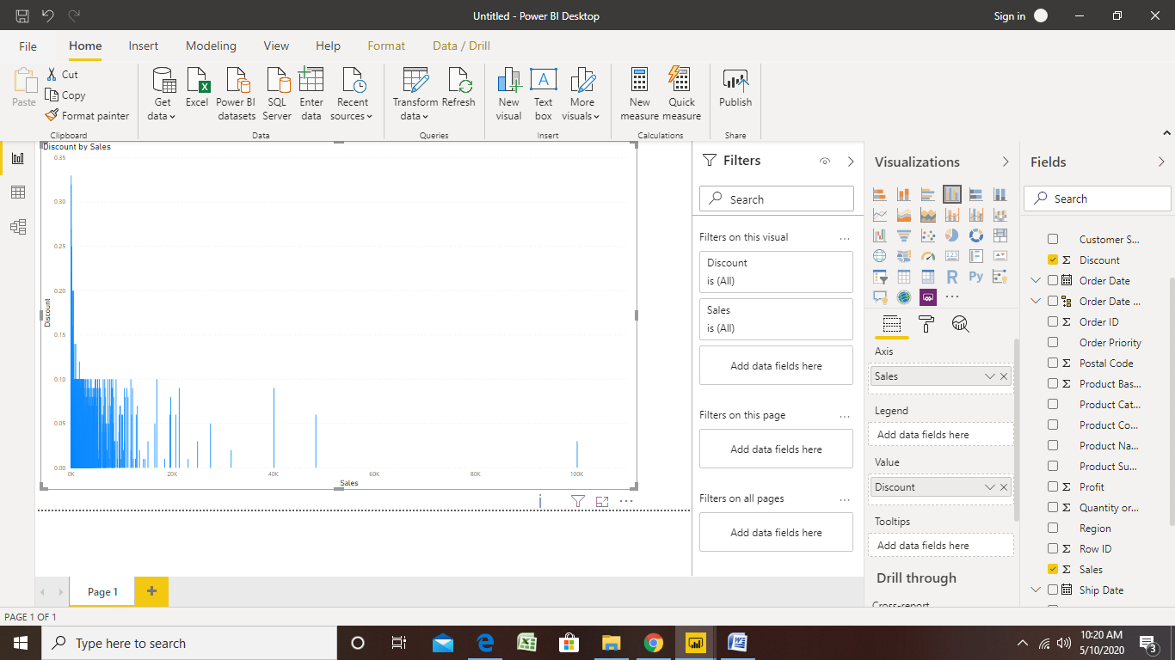

**Which state has the highest sales in terms Technology**

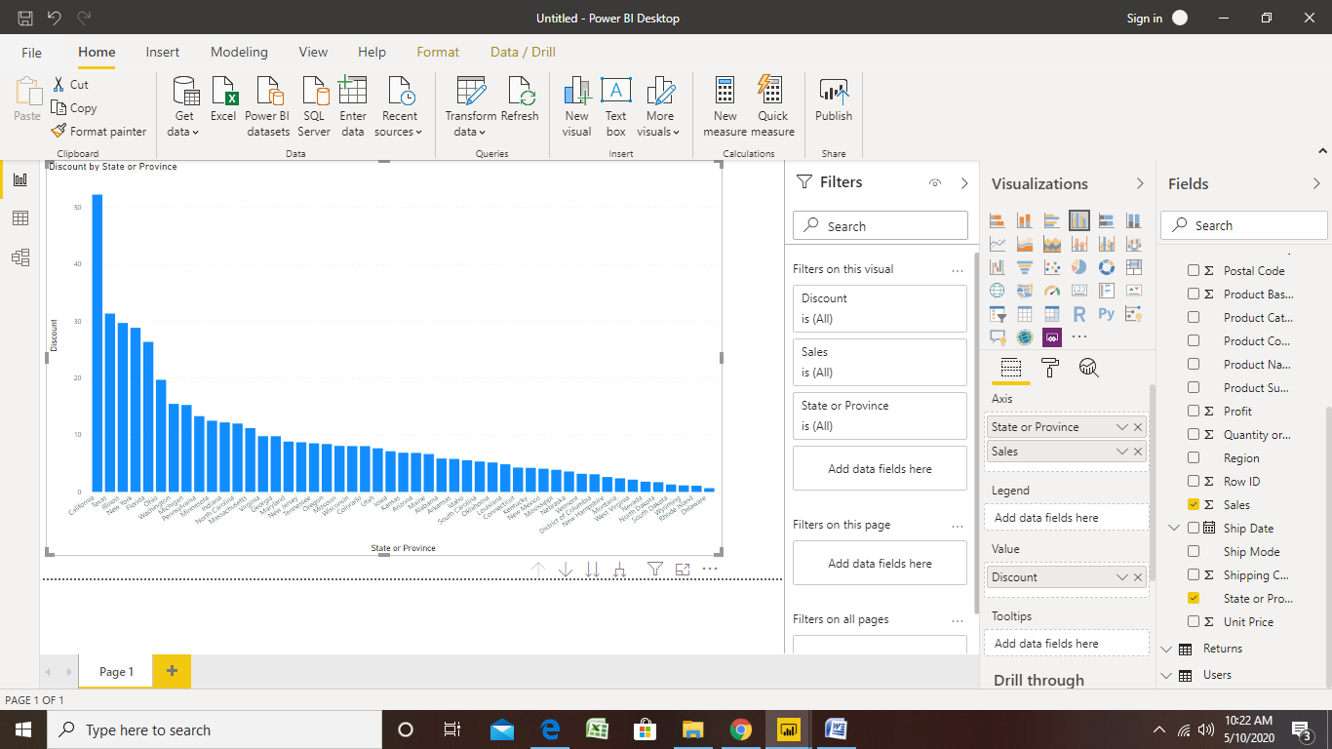

**Create a Donut Chart showing sales in terms of Product category:**

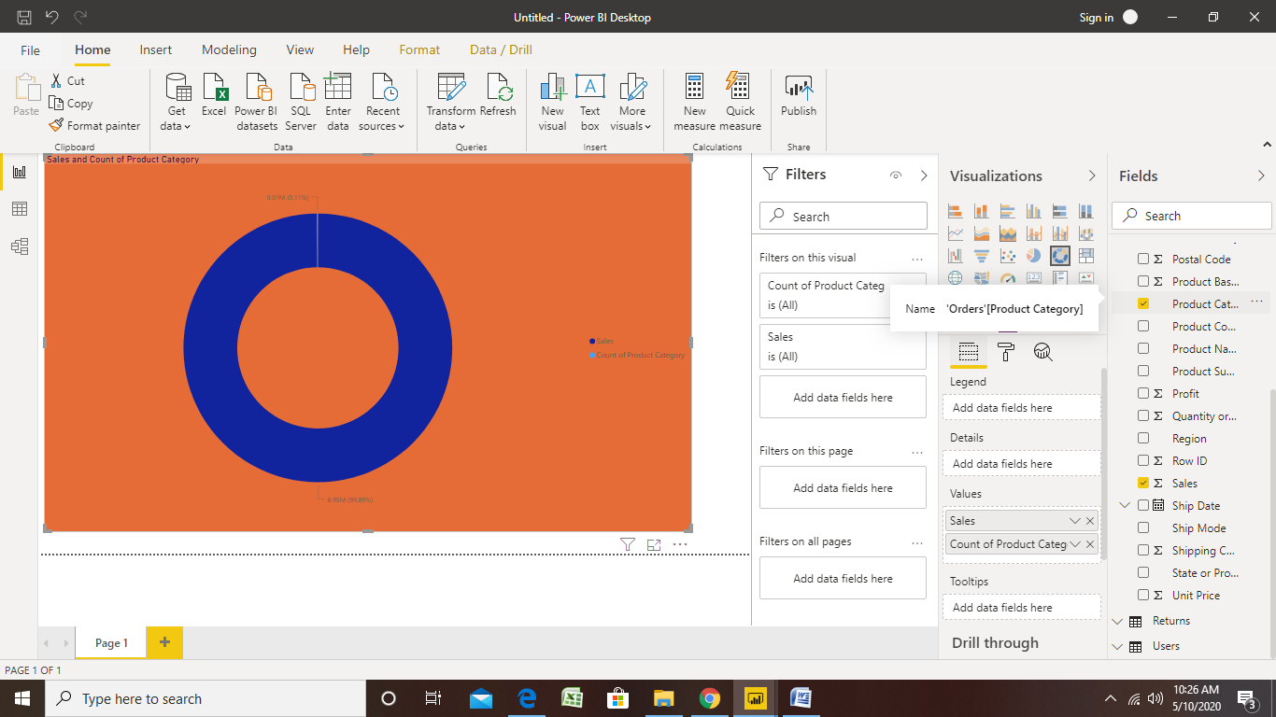

**Create a Slicer and show the regions in dropdown. See how all the visuals mentioned above behaving when a particular region is selected**

